STABILIZED VACANT UNITS TRACKER
Fund-Level Analysis

Template Methodology & Formula Reference

1. Purpose & Overview

This document explains the methodology, data sources, formulas, and decision logic underpinning the Stabilized Vacant Units Tracker — a fund-level Excel analysis tool built to track, prioritize, and recommend actions for all rent-stabilized units that are currently vacant across a portfolio of properties.

The tracker consolidates data from multiple property management reports into a single, actionable view that allows asset managers to:
- Monitor how long each stabilized unit has been vacant and categorize its aging tier
- Understand the root cause of vacancy through automated keyword-based reason classification
- Compare the stabilized (max legal) rent against current market rent to identify pricing gaps
- Evaluate renovation status and whether a light or full renovation could close the rent gap
- Receive a specific, pre-defined Suggested Next Step and Recommended Action for every unit

1.1 Scope
The tracker covers all rent-stabilized vacant units across the Fund's properties as of the tracker date. Units from sold properties are excluded. Each row represents one unit, with data automatically pulled from six underlying source sheets through VLOOKUP, AVERAGEIFS, MAXIFS, INDEX/MATCH, and Array formulas.

1.2 Tracker Date
Cell C4 holds the "Tracker as of" date. Several dynamic column headers reference this date using TEXT($C$4,"mm/dd/yyyy"), so headers automatically update when the tracker date is changed.

2. Workbook Architecture & Data Sources

The workbook is organized into nine sheets. The Summary Sheet is the primary output; the remaining eight sheets are either raw data feeds or lookup reference tables.
Sheet Name | Role | Description
Summary Sheet | Output | Primary tracker — one row per stabilized vacant unit. All formulas live here.
Summary Sheet (2) | Output | Alternate / backup version of the summary tracker (same structure).
RR (T-0) | Source Data | Full rent roll at current date — contains rent amounts, unit types, property codes, and "Rent Controlled" flag used to identify stabilized max rents.
Last Move Out | Source Data | Move-out reasons report (date range 2021–present) — contains move-in date, move-out date, notice date, and move-out reason per tenant/unit.
Job Reno Tracker | Source Data | Renovation job tracker — contains current reno type and renovation completion date per unit.
Custom Unit Availability Listing | Source Data | Turn status report — shows current leasing/availability status of each unit.
Amenities | Source Data | Tenant-level records with lease dates, move-in/out dates, and amenity dollar amounts.
Unit Type Vacancy | Source Data | Unit-level vacancy data including days vacant, rent, square footage, comments, and stabilized flag.
Lookup | Reference | Master mapping table: property names → short names, entity names, funds, regions, unit-type standardization, and the Stabilized Unit List (the definitive list of units included in the tracker).

2.1 Unique Key / Concatenation Logic
Every cross-sheet lookup uses a composite key formed by concatenating the Unit Number with the Property Entity Name. This avoids collisions where the same unit number exists across different properties.

Composite Key (used in all lookups)
Formula | CONCAT(UnitNumber, VLOOKUP(PropertyName, Lookup!H:M, 6, FALSE))
Logic | Unit number from column C is joined with the entity name returned from the Lookup sheet (column 6 of range H:M). For example, unit "2A" at "Entity 5" produces key "2AEntity 5". This key is pre-computed in the Unit Type Vacancy, Amenities, Job Reno Tracker, and Custom Unit Availability sheets to enable fast lookups.

3. Column-by-Column Formula Reference

The table below maps every column in the Summary Sheet to its data source, formula pattern, and plain-language logic.

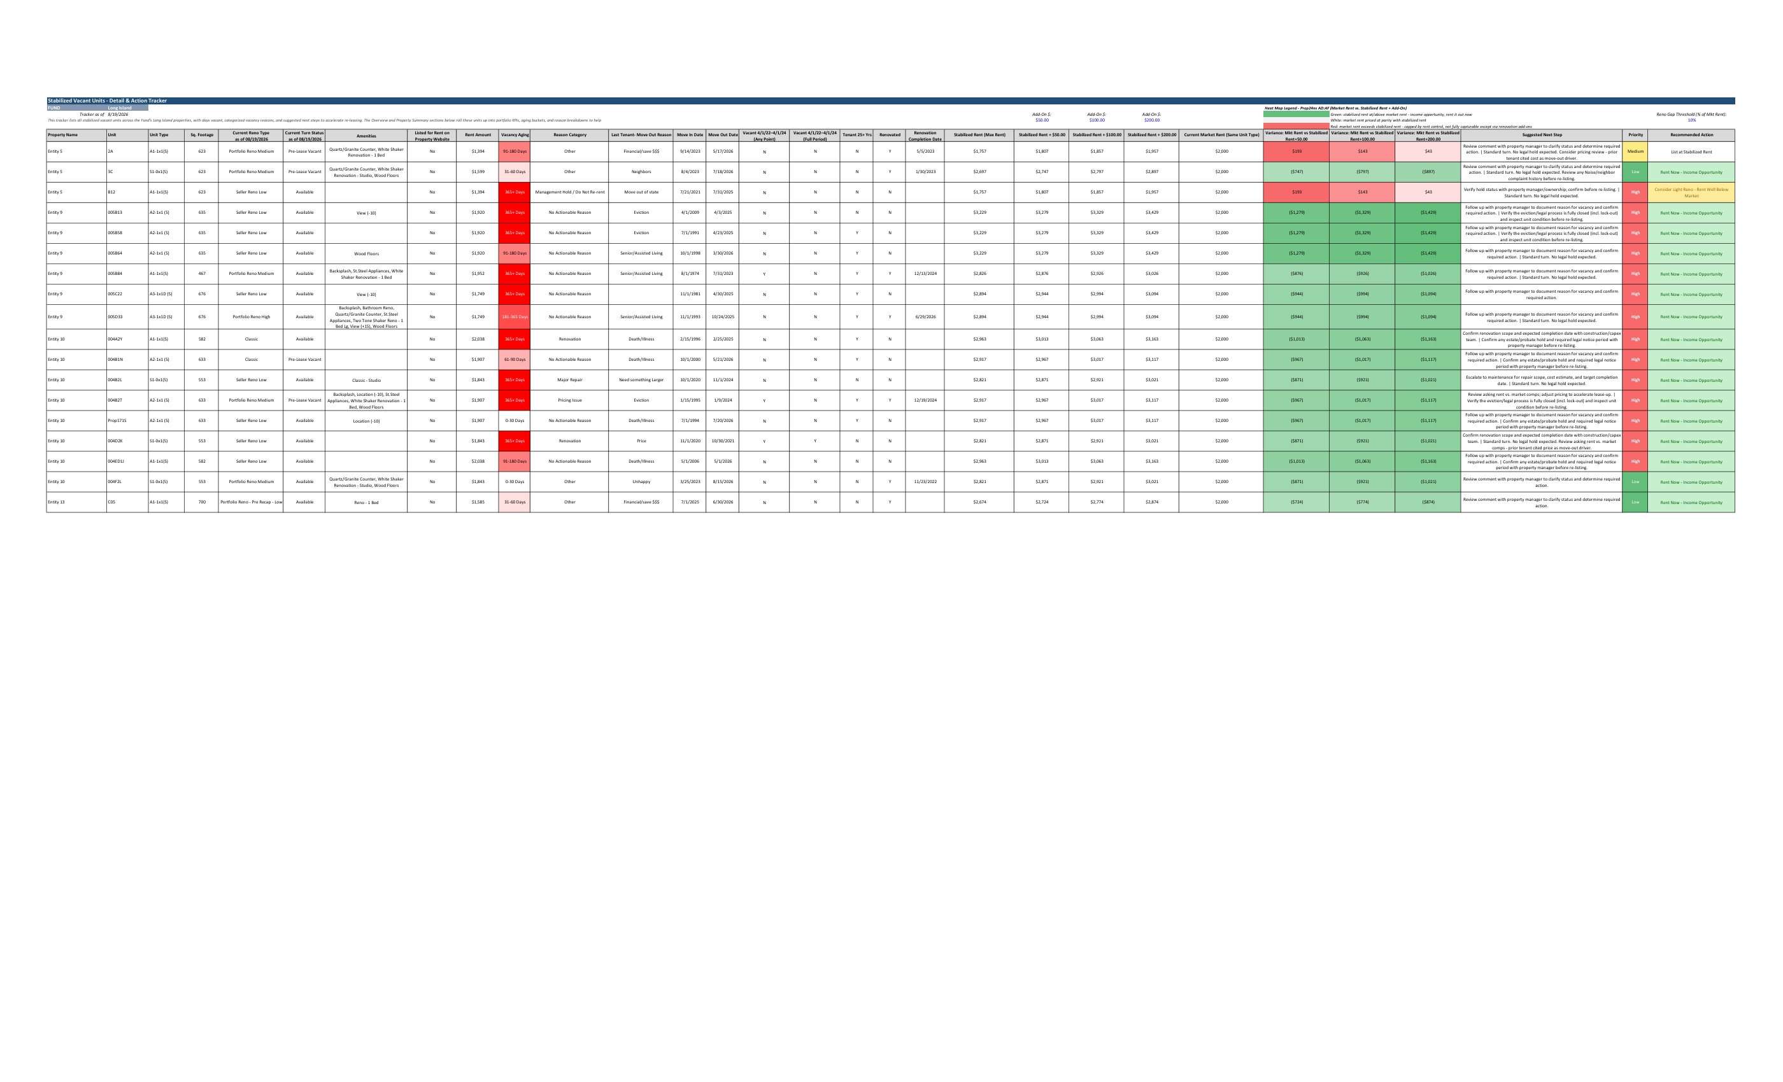
Figure 1 — Stabilized Vacant Units Tracker: Summary Sheet output (masked data)

3.1 Unit Identity Columns (B – G)

Column | Header | Formula / Logic
B | Property Name | Hardcoded — entered manually when populating the unit list. Serves as the primary property identifier for all VLOOKUP calls.
C | Unit | Hardcoded — the unit number. Used as the first component of the composite key.
D | Unit Type | VLOOKUP(CONCAT(C,EntityName), RR(T-0)!A24:T15829, 20, FALSE) — looks up the unit type (e.g., "2 Bed 1 Bath") from the rent roll using the composite key.
E | Property Short Name | VLOOKUP(VLOOKUP(B, Lookup!H:M, 6), Lookup!F:G, 2, FALSE) — two-step lookup: first resolves entity name from property name, then resolves the short display name.
F | Default Address | VLOOKUP(CONCAT(C, EntityName), UnitTypeVacancy!A:E, 5, FALSE) — retrieves the street address for the unit from the Unit Type Vacancy sheet.
G | Sq. Footage | VLOOKUP(CONCAT(C, EntityName), Amenities!B:H, 7, FALSE) — pulls square footage from the Amenities sheet using the composite key.

3.2 Operational Status Columns (H – K)

Column | Header | Formula / Logic
H | Current Reno Type (as of date) | VLOOKUP(CONCAT(C, B), JobRenoTracker!B5:W, 22, FALSE) — pulls the current renovation classification (e.g., "Portfolio Reno Medium", "Seller Reno Low", "Classic") from column 22 of the Job Reno Tracker.
I | Current Turn Status (as of date) | VLOOKUP(CONCAT(C, B), CustomUnitAvailabilityListing!A:B, 2, FALSE) — fetches the current leasing/turn status (e.g., "Available", "Pre-Lease Vacant") from column 2 of the Custom Unit Availability Listing.
J | Amenities | IFERROR(IF(VLOOKUP(..., Amenities, 12)=0, "", VLOOKUP(..., Amenities, 12))) — retrieves the total amenity dollar value from column 12 of the Amenities sheet; returns blank if zero.
K | Listed for Rent on Property Website | Hardcoded field — manually entered "Yes" or "No" by the analyst to flag whether the unit is actively listed.

3.3 Rent & Vacancy Metrics (L – N)

Col L — Rent Amount (Avg Rent for Unit Type at Property)
Formula | IFERROR(AVERAGEIFS(RR!F:F, RR!L:L, PropertyName, RR!T:T, UnitType, RR!F:F, ">0"), "")
Logic | Computes the average rent across all occupied units of the same unit type at the same property using AVERAGEIFS with three criteria: matching property name (from Lookup via INDEX/MATCH), matching unit type, and a positive rent amount. This benchmarks what comparable stabilized units are currently renting for.

Col M — Days Vacant
Formula | VLOOKUP(CONCAT(C, EntityName), UnitTypeVacancy!A:H, 8, FALSE)
Logic | Pulls the number of days the unit has been vacant directly from the Unit Type Vacancy sheet (column 8). This is computed upstream in that sheet from current date minus move-out date.

Col N — Vacancy Aging (Array Formula)
Formula | {=IF(M9<=30,"0-30 Days",IF(M9<=60,"31-60 Days",IF(M9<=90,"61-90 Days",IF(M9<=180,"91-180 Days",IF(M9<=365,"181-365 Days","365+ Days")))))}
Logic | Array formula that buckets days vacant into six aging tiers: 0–30, 31–60, 61–90, 91–180, 181–365, and 365+ days. These tiers drive the Vacancy Aging Distribution chart in the Visual Summary and are used for heat-map colouring.

3.4 Vacancy Reason Classification (O – P)

These two columns work together: column O holds the free-text comment from the property manager, and column P automatically classifies that comment into a standardized reason category.

Col O — Comment (Free-Text)
Formula | IFERROR(IF(VLOOKUP(CONCAT(C, EntityName), UnitTypeVacancy!A:F, 6)=0, "", VLOOKUP(..., 6)), "")
Logic | Retrieves the property manager's free-text comment for the unit from column 6 of the Unit Type Vacancy sheet. Returns blank if empty.

Col P — Reason Category (Keyword Array Formula)
Formula | {=IFERROR(INDEX(KeywordTable[Category], MATCH(1, ISNUMBER(SEARCH(KeywordTable[Keyword], O9)), 0)), "No Actionable Reason")}
Logic | Array formula that scans the free-text Comment (col O) for any keyword in the reference table at rows 142–153. SEARCH is case-insensitive; ISNUMBER converts a match to TRUE; MATCH finds the first TRUE; INDEX returns the corresponding category. If no keyword matches, it returns "No Actionable Reason".

The keyword-to-category mapping (embedded in the Summary Sheet as a reference table) is:
Keyword (searched in Comment) | Reason Category | Suggested Next Step
"do not re-rent" | Management Hold / Do Not Re-rent | Verify hold status with property manager/ownership; confirm before re-listing.
"hold" | Management Hold / Do Not Re-rent | Verify hold status with property manager/ownership; confirm before re-listing.
"renovat" | Renovation | Confirm renovation scope and expected completion date with construction/capex team.
"repair" | Major Repair | Escalate to maintenance for repair scope, cost estimate, and target completion date.
"too low" | Pricing Issue | Review asking rent vs. market comps; adjust pricing to accelerate lease-up.
"pricing" | Pricing Issue | Review asking rent vs. market comps; adjust pricing to accelerate lease-up.
"electric" | Utility/Building Issue | Coordinate with maintenance/utility provider to resolve issue before re-listing.
"plumbing" | Utility/Building Issue | Coordinate with maintenance/utility provider to resolve issue before re-listing.
"basement" | Utility/Building Issue | Coordinate with maintenance/utility provider to resolve issue before re-listing.
"hvac" | Utility/Building Issue | Coordinate with maintenance/utility provider to resolve issue before re-listing.
"boiler" | Utility/Building Issue | Coordinate with maintenance/utility provider to resolve issue before re-listing.
(no match) | No Actionable Reason | —

3.5 Tenant History Columns (Q – W)
These columns reconstruct the last tenancy record for the unit, pulled from the Last Move Out report, and apply several rent-stabilization regulatory flag checks.

Col Q — Last Tenant Move-Out Reason (Array Formula)
Formula | {=IFERROR(INDEX(LastMoveOut!F:F, MATCH(1, (LastMoveOut!B:B=CONCAT(C,EntityName))*(LastMoveOut!J:J=MAXIFS(LastMoveOut!J:J,LastMoveOut!B:B,CONCAT(C,EntityName))), 0)), "")}
Logic | Array formula that finds the move-out reason for the most recent departure from this unit. Uses MAXIFS to identify the latest move-out date for the unit key, then uses INDEX/MATCH with a dual-condition array to retrieve the corresponding reason.

Col R — Move-In Date (Array Formula)
Formula | {=IFERROR(INDEX(LastMoveOut!G:G, MATCH(1, (LastMoveOut!B:B=CONCAT(C,EntityName))*(LastMoveOut!J:J=MAXIFS(...)), 0)), "")}
Logic | Same pattern as col Q — retrieves the Move-In Date (column G of Last Move Out) for the most recent tenant of the unit.

Col S — Move-Out Date
Formula | IFERROR(IF(MAXIFS(LastMoveOut!J:J, LastMoveOut!B:B, CONCAT(C, EntityName))=0, "", MAXIFS(...)), "")
Logic | Returns the latest move-out date recorded for the unit using MAXIFS. If no move-out date exists (unit may never have been occupied), returns blank.

Col T — Move-Out Step Addendum
Formula | IFERROR(INDEX($C$157:$C$164, MATCH(Q9, $B$157:$B$164, 0)), "")
Logic | Looks up the move-out reason (col Q) in the Move-Out Reason Next Step Overlay table (rows 157–164) and returns the corresponding addendum text. For example, "Death/Illness" triggers a note to confirm estate/probate hold; "Eviction" triggers a note to verify the legal process is fully closed.

Column | Header | Formula / Logic
U | Vacant 4/1/22–4/1/24 (Any Point) | =IF(S="","N",IF(S<=DATE(2024,4,1),"Y","N")) — flags "Y" if move-out date is on or before April 1, 2024, indicating the unit was vacant at any point in the 2022–2024 window. Relevant for rent-stabilization regulatory tracking.
V | Vacant 4/1/22–4/1/24 (Full Period) | =IF(S="","N",IF(S<=DATE(2022,4,1),"Y","N")) — flags "Y" only if move-out was on or before April 1, 2022, meaning the unit was vacant for the full 2-year window.
W | Tenant 25+ Years | =IF(OR(R="",S=""),"N",IF((S-R)>=25*365.25,"Y","N")) — computes tenancy duration by subtracting move-in from move-out date. Flags "Y" if ≥25 years (9,131.25 days). 365.25 accounts for leap years.
X | Renovated | =IF(OR(H="",H="Classic",H="Seller Reno Low"),"N","Y") — flags whether the unit has received a meaningful renovation. "Classic" and "Seller Reno Low" classifications are treated as un-renovated.
Y | Renovation Completion Date | VLOOKUP(CONCAT(C,B), JobRenoTracker!B5:P, 15, FALSE) — retrieves the renovation completion date from column 15 of the Job Reno Tracker.

3.6 Rent Comparison & Add-On Columns (Z – AG)

These columns form the core rent-gap analysis of the tracker, comparing the legally permissible stabilized rent against current market rent at three add-on price scenarios.

Col Z — Stabilized Rent / Max Rent (LRR)
Formula | IFERROR(MAXIFS(INDEX(RR!A:ZZ, 0, MATCH("LRR", RR!24:24, 0)), RR!C:C, "*Rent Controlled*", RR!L:L, EntityName, RR!T:T, UnitType, RR!N:N, Unit), "")
Logic | Finds the Last Regulated Rent (LRR) — the maximum legal rent — for the unit. Uses MAXIFS across the rent roll with three conditions: property type contains "Rent Controlled", entity name matches, unit type matches, and unit number matches. MATCH is first used to dynamically locate the "LRR" column header in row 24 of RR(T-0), making the formula resilient to column reordering.

Column | Header | Formula / Logic
AA | Stabilized Rent + $50 | =IF(OR(Z="",Z=0), "", Z+$AA$5) — adds the first add-on threshold ($50, stored in cell AA5) to the stabilized rent. Returns blank if no stabilized rent exists.
AB | Stabilized Rent + $100 | =IF(OR(Z="",Z=0), "", Z+$AB$5) — adds the second add-on threshold ($100).
AC | Stabilized Rent + $200 | =IF(OR(Z="",Z=0), "", Z+$AC$5) — adds the third add-on threshold ($200).
AD | Current Market Rent (Same Unit Type) | Hardcoded — entered by the analyst as the prevailing market rent for the same unit type at that property. Used as the benchmark for variance calculations.
AE | Variance: Mkt Rent vs Stabilized + $50 | =IF(OR(AD="",AA=""),"",AD-AA) — market rent minus (stabilized + $50). Positive = market rent is higher (rent gap exists). Negative = stabilized rent already at/above market.
AF | Variance: Mkt Rent vs Stabilized + $100 | =IF(OR(AD="",AB=""),"",AD-AB) — same calculation with $100 add-on.
AG | Variance: Mkt Rent vs Stabilized + $200 | =IF(OR(AD="",AC=""),"",AD-AC) — same calculation with $200 add-on.

3.7 Heat Map Legend (Columns AD – AG)

Conditional formatting is applied to columns AD–AG to provide an instant visual signal of rent positioning relative to market:

Colour | Meaning
Green | Stabilized rent is at or above market rent — unit can be leased immediately at a competitive rent. Income opportunity.
White | Market rent is approximately at parity with the stabilized rent — neutral position.
Red | Market rent exceeds stabilized (max legal) rent — the unit is capped by rent control and the full market premium cannot be captured except via qualifying renovation add-ons.

3.8 Action Recommendation Columns (AH – AJ)

Col AJ — Recommended Action (Decision Tree)
Formula | =IF(Z="","",IF(Z>=AD,"Rent Now - Income Opportunity",IF(AND(X="N",(AD-Z)>=$AJ$5*AD),"Consider Light Reno - Rent Well Below Market","List at Stabilized Rent")))
Logic | Three-way decision tree: (1) If stabilized rent ≥ market rent → "Rent Now – Income Opportunity"; (2) If unit is NOT renovated AND the rent gap ≥ the Reno Gap Threshold (cell AJ5, default 10% of market rent) → "Consider Light Reno – Rent Well Below Market"; (3) Otherwise → "List at Stabilized Rent". The 10% threshold is configurable in AJ5.

Column AH (Suggested Next Step) and column AI (Priority) are array formulas that cross-reference the Reason Category (col P), keyword next-step table, and move-out step addendum (col T) to produce a consolidated action narrative and urgency ranking for each unit.

4. Lookup Sheet — Master Reference

The Lookup sheet is the backbone of the tracker. It contains four key reference structures:

4.1 Property Master Table (Columns F–M)
Maps each property name to its short name, entity name, unit count, fund, and region. Used by virtually every VLOOKUP in the Summary Sheet to resolve identifiers.

4.2 Unit Type Standardization (Columns B–C)
Maps verbose unit type descriptions from the rent roll (e.g., "1 Bed 1 Bath + Den") to standardized groupings (e.g., "0–1 Bed", "2 Bed") used for rent averaging in column L of the Summary Sheet.

4.3 Stabilized Unit List (Columns N–Q)
Column P (labelled "EDIT HERE FOR ANY CHANGE IN STABILIZED UNIT LIST") contains the master list of unit numbers that belong to stabilized properties. Column Q computes the composite key CONCAT(P, PropertyName). The Unit Type Vacancy sheet's column M uses IFERROR(VLOOKUP(concat, Lookup!Q:Q, 1, FALSE), "") to flag each unit as stabilized or not — this is the filter that determines which units appear in the tracker.

4.4 Sold Properties Reference (Column AC)
Lists entity names of properties that have been sold and should be excluded from the tracker. Logic in the Unit Type Vacancy sheet suppresses these units.

5. Visual Summary & Dashboard

The second page of the tracker output contains a Visual Summary with three pre-built charts and a property comparison table, all driven by formulas in the Summary Sheet.
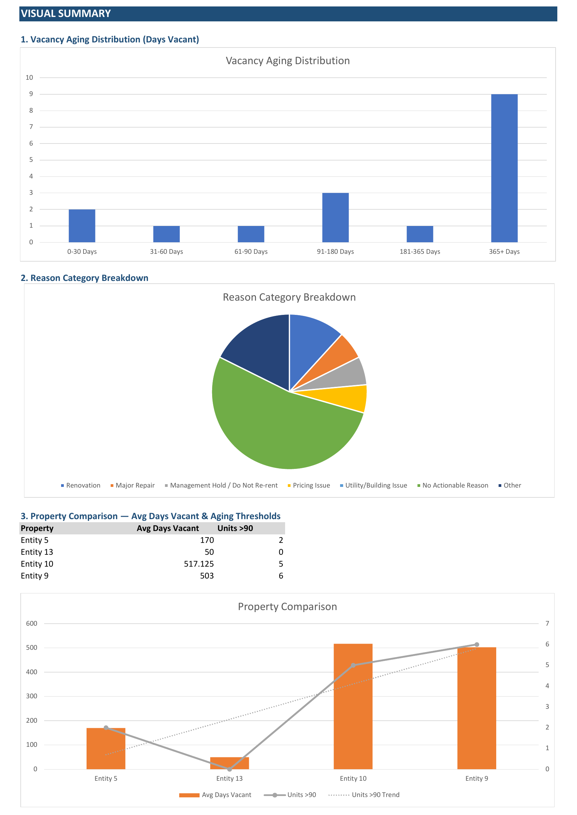
Figure 2 — Visual Summary: Vacancy aging distribution, reason breakdown, and property comparison

5.1 Chart 1 — Vacancy Aging Distribution
A bar chart that groups all vacant units by their Vacancy Aging tier (column N): 0–30, 31–60, 61–90, 91–180, 181–365, and 365+ days. Driven by COUNTIFS against column N. This chart immediately surfaces the severity of long-duration vacancies.

5.2 Chart 2 — Reason Category Breakdown
A pie chart that counts units by Reason Category (column P). Categories include Renovation, Major Repair, Management Hold/Do Not Re-rent, Pricing Issue, Utility/Building Issue, No Actionable Reason, and Other. Helps identify the dominant vacancy driver across the portfolio.

5.3 Chart 3 — Property Comparison (Avg Days Vacant & Units >90 Days)
A combo chart (bar + line) comparing properties on two metrics: average days vacant (orange bars, left axis) and number of units vacant more than 90 days (grey line with markers, right axis). A dotted trend line shows the trajectory across properties. This surfaces which assets carry the most acute vacancy risk and require priority attention.

6. Result Analysis

The following analysis is drawn from the tracker output as of August 19, 2026, covering stabilized vacant units across the fund of portfolio (Entities 5, 9, 10, and 13).

6.1 Portfolio-Level Vacancy Summary

Metric | Value | Observation
Total stabilized vacant units tracked | ~18 units | Across 4 fund entities
Units vacant 365+ days | 9 units (majority) | Largest aging bucket — chronic vacancy
Units vacant 91–180 days | 3 units | Sub-acute; require urgent action
Units vacant 0–90 days | ~6 units | Recent turnover; normal lease-up pipeline

The vacancy aging distribution is heavily right-skewed, with the majority of units concentrated in the 365+ days bucket. This indicates that the portfolio's vacancy problem is primarily structural (renovation, regulatory, or pricing) rather than transactional.

6.2 Reason Category Breakdown

The Reason Category pie chart reveals the following vacancy drivers (approximate breakdown based on tracker output):
- Renovation — the largest category, reflecting units undergoing or awaiting renovation scope approval. These units are intentionally off-market pending capex work.
- No Actionable Reason — a significant share of units carry no comment or an ambiguous comment, suggesting a gap in property manager reporting that needs to be addressed.
- Management Hold / Do Not Re-rent — a portion of units are on deliberate hold by ownership or property management.
- Major Repair — units with physical plant issues (HVAC, plumbing, electrical) preventing re-listing.
- Pricing Issue — a smaller but notable category where the comment suggests the asking rent is misaligned with demand.
- Utility/Building Issue — isolated cases with building-system or utility access barriers.

Renovation and No Actionable Reason combined represent the majority of vacancy, which means the primary lever to reduce vacancy is accelerating renovation completions and improving property manager comment quality.

6.3 Property-Level Comparison

Property (Entity) | Avg Days Vacant | Units >90 Days | Urgency
Entity 10 | 517 days | 5 units | Critical
Entity 9 | 503 days | 6 units | Critical
Entity 5 | 170 days | 2 units | Elevated
Entity 13 | 50 days | 0 units | Normal

Entity 10 and Entity 9 are the highest-priority assets, with average vacancy durations exceeding 500 days and the highest unit counts above the 90-day threshold. Entity 13 is the healthiest performer, with no units exceeding 90 days vacant and a sub-60-day average — suggesting its property management and leasing processes are functioning well and can serve as a benchmark.

6.4 Rent Positioning & Recommended Actions

The heat-map analysis across columns AD–AG highlights the following strategic positions:
- Several units at Entity 5 show stabilized rent at or above current market rent (green heat-map) — these units should be listed immediately without renovation, as they represent direct income opportunities.
- The majority of units at Entity 9 and Entity 10 show market rent exceeding stabilized rent (red heat-map) — these are rent-controlled units where the income upside is capped. For un-renovated units with a rent gap exceeding 10% of market rent, the Recommended Action column flags "Consider Light Reno" to qualify for renovation add-ons under rent stabilization rules.
- Units classified as "Renovation" in the reason category at Entity 9 and Entity 10 represent the largest single opportunity: completing these renovations unlocks both the add-on and an accelerated path to re-leasing.

The tracker's three-tier Recommended Action framework (Rent Now / Consider Light Reno / List at Stabilized Rent) allows asset managers to immediately triage each unit without additional analysis.

6.5 Key Takeaways

- 9 of the ~18 tracked units have been vacant for over a year — this represents the most acute revenue leakage in the portfolio.
- Entity 9 and Entity 10 together account for 11 of the 13 units vacant more than 90 days and require immediate escalation.
- Renovation pipeline acceleration at these two entities is the single highest-leverage action available to the fund.
- The tracker's automated comment-to-category classification and Suggested Next Step column eliminate manual interpretation, enabling property managers to act directly from the output.
- Entity 13's performance (avg 50 days vacant, 0 units >90 days) demonstrates that rapid turnaround is achievable within the same fund — this benchmark should be communicated to underperforming property managers.

